Study of Steady-State of Steering of Multi-Steering-Axle Tank Vehicles

Der-Ho Wu*, Wen-Tung Chien*and Yu-Hung Lin**

Keywords：multi-steering-axle, tank vehicles, sloshing.

ABSTRACT

The purpose of this paper is to study the steady turning dynamics of tank vehicles with multiple steering axles and filled with chemical liquid cargo. The lateral forces and moments due to the liquid sloshing is one of the most serious problems strongly related to roll instability of tank vehicles. In this paper, the lateral acceleration characteristic of a circular-tank vehicle with multi-steering axles during steady turning is investigated at various filling level and speed via numerical analysis, this study concludes that the multiple steering wheels reduce the lateral forces caused by the liquid shift and decrease the rotation radius during steady turning which gives rise to roll and lateral instabilities.

INTRODUCTION

Commercial tank vehicles have been increasing by used in road transport. Their safety of handling has seriously concerned us. In the operation of a bulk-liquid transport vehicle, the movement of the liquid from side to side due to partial filling of the tank produces the sloshing force. The liquid slosh within a tank increases the roll moment and may lead to the rollover and is of potential safety concern because the lateral shift of the load reduces the vehicle’s stability and controllability in cornering and turning, and the dynamic motions of load may occur out of phase with The study of sloshing-force behavior of fluid flow the vehicle’s lateral motions and decrease the rollover threshold. Among the lateral dynamic maneuver that a tank vehicle can experience, rollover is one of the most serious and
Paper Received June, 2003. Revised September, 2003. Accepted October, 2003. Author for Correspondence: Der-Ho Wu.

* Associate Professor, Department of Mechanical Engineering, National Pintung University of Science and Technology, Pingtung, Taiwan 91207, ROC.

** Graduate Student, Department of Mechanical Engineering, National Pintung University of Science and Technology, Pingtung, Taiwan 91207, ROC.

threatening to the vehicle occupant. within the moving tank vehicle involves quite complex dynamic modeling and analyses due to the dependence of the motions on tank size and geometry, the mass and the viscosity of the moving liquid. Many studies have been carried out regarding the dynamic stability of tank-truck and tank articulated vehicles. Most papers (Ranganathan, 1989, 1990; Rakheja, 1988; Kang et al., 2000) developed three-dimensional roll models of tank vehicles by assuming the fluid being in quasi-steady state. Linearized equations of motion for the system were obtained and the directional stability and response to steer during cornering at constant speed with single steering wheel were examined. The use of additional steering axles on a vehicle has received attention since 1980s. Furleigh et al.(1988) based on four-wheel steering characteristics (Sano et al., 1986; Bernard et al., 1988), designed the multi-steering-axle semi-trailer which has reduced lateral acceleration and increased maneuverability. LeBlane et al. (1989) presented a self-steering axle for trailer and Aurell and Edlund (1989) studied the effect of the steering axles on the dynamic stability of trailer unit of heavy vehicles. Recently, Wu (2001) first modeled the yaw/roll motion of an active multi-steering-axle tractor and trailer. According to previous studies, the multi-steering-axle articulated vehicles have a lower lateral acceleration of the trailer center of gravity, a higher the maneuverability, and a lower tyre wear and road wear. Whereas, most authors have focused on the directional motion of multiple steering-axle vehicles with rigid cargo and have nearly not mentioned the slosh force of fluid tank.
In this paper, a quasi-steady state model of fluid bulk within the tank is established and integrated with the multiple steering yaw/roll model to investigate the directional response at constant forward speed with steady steer input. The influences of the additional steering wheel on the yaw/roll motions, filling variation and liquid load shift on the steering response of the tank vehicle are studied and compared to that of traditional vehicle with single steering to demonstrate that the multiple steering increases the maneuverability and decreases the destabilizing effects of liquid load shift.

THE DYNAMICS OF TANK VEHICLE WITH MULTIPLE STEERING AXLES

A multi-steering-axle tank vehicle with circular section tank is presented to study the influence of the liquid load shift on the directional dynamics of the vehicle. The tank vehicle is modeled as a quasi-steady state three-dimensional roll plane model of the tank, and is assumed at a constant forward speed. A schematic sketch of the tank truck model considered in this study is shown in Fig. 1.
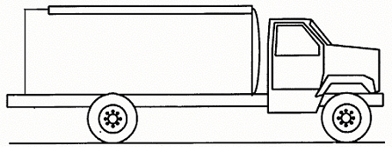

Fig. 1. The diagram of the tank truck vehicle.

Roll Plane Model of a Partially Filled Circular Tank
In this study, the liquid within the tank is assumed to move as a rigid body, due to the roll and lateral acceleration imposed by the vehicle during a constant-speed highway maneuver, as shown in Fig.2. The gradient of the free surface can be obtained by assuming inviscid fluid flow and small roll angels of sprung mass and the coordinates of center of mass of fluid in a partially filled circular tank expressed as (Ranganathan, 1990),

Fig. 2. The principal representation of the axles and suspension in the roll plane of tank vehicle.
, (1)
where is the roll angle of the sprung mass and a_{l} is the acceleration of liquid.

Center of Acceleration of the Liquid Mass
The fluid can be assumed to move as a rigid body and the acceleration of the liquid bulk is computed from the sprung mass and the instantaneous center of the gravity of the liquid bulk with respect to the C.G. of truck. The pitch and vertical motions of sprung mass are neglected in this study; then the acceleration of the truck sprung weight is expressed as

(2)
where represent the unit vectors along the sprung mass coordinate, (u, v, w) and (p, q, r ) are the linear velocities and rotational velocities of sprung mass along the sprung mass coordinates respectively. Based on previous assumptions, w, q, and r are assumed to be zero in this study.
The coordinates of the instantaneous centre of mass of liquid (Y_{l}, Z_{l}) with respect to the tank truck C.G. are expressed in the following form
Y_{l} = (R – Z_{l0}) sinφ, (3)
Z_{l} = R – (R – Z_{l0}) cosφ,

where R is the tank radius, and Z_{l0} is the height of the centre of the liquid mass in absence of tank roll and lateral accelerations.

Dynamic Modeling of Tank Vehicle
A three-degree-of-freedom tank vehicle is modeled in this study. Both yaw and roll degrees of freedom must be considered simultaneously to predict the directional dynamics to obtain accurate results for the lateral stability of the system. The task of deriving reasonable mathematic yaw/roll model of the multi-steering-axle tank vehicle and performing dynamic stability on the system is a challenging work. This work requires the use of assumption and approximations, which linearize the equations of motion. In the analysis of yaw/roll model of an articulated vehicle presented here, three degrees of freedom are considered, corresponding to sideslip, yaw and roll motion. The original tank vehicle model considered here is based on Wu (2001) multiple steering method and Ranganathan (1990), rigid steady liquid model. The air resistance, braking input, and vertical or pitch motion are neglected for the sake of simplicity.
As in the simplified model, the wheels of system are located on the centre line of the vehicle and axle set is represented by one wheel from Fig. 3. The original coordinate system is fixed on the centre of the tank vehicle and moving with it. The equations of motion for the tank vehicle are derived from the forward speed V_{x}, side slip velocity V_{y}, yaw angle Φ, and the roll angle of the sprung mass θ. δ_{f} and δ_{r} represent the steering angles of front wheel and rear wheel respectively. Assume the lateral forces exerted on the tyres by the road are the mainly concerned external forces acting on the vehicle.

Fig. 3. The principal representation of the yaw model for tank vehicle.

To predict the directional responses of tank vehicles in turning maneuvers is a challenging work. In the model, the forward speed of the vehicle is assumed to remain constant during the maneuver and several assumptions are made to eliminate the nonlinear properties. The basic assumptions are (a) nonlinear behaviors of the springs and dampers are not taken into account, (b) the cornering force produced by a given tyre is a linear function of the slip angle and (c) the influence of wheel camber on lateral force generation and aligning moment are neglected. Then the linearized equations can be achieved and analyzed more easily.
According to Newton's second law, the equations of motion for the tank vehicle can be expressed in terms of the moving X, Y coordinates as follows:
Lateral motion:
m( + )﹣m₁ Z_{l} = F_{yf} cosδ_{f} + F_{yr} cosδ_{r.},

Yaw motion:
I_{z} ﹣I_{xz} = F_{yf} s₁ cosδ_{f} ﹣F_{yr} s₂ cosδ_{r .} (4)
Roll Motion:
I_{x}$\frac{d^{2}θ}{{\text{dt}}^{2}}$﹣I_{xz} $\frac{d^{2}Φ}{{\text{dt}}^{2}}$ + m_{l} Z_{l} ($\overset{\text{.}}{V_{y}}$+$V_{x}$$\frac{dΦ}{\text{dt}}$) = (﹣K_{θ} + m_{l} gZ_{l} ) θ﹣C_{θ} $\frac{dθ}{\text{dt}}$+m_{l} gY_{l} ,
where K_{θ} is the roll stiffness coefficient, C_{θ} is the roll damping coefficient, and Z_{l} is the roll height (distance between roll axis and mass center of sprung mass) of the tank vehicle.
The lateral force of tyre is the main concern for vehicle directional stability whereas is the lateral force is produced by a side slip angle of tyre. In this study, the lateral force is assumed as a linear function of the side slip angle, if this angle is reasonably small. Hence, the lateral force F_{yi} can be expressed by the form as
F_{yi} = C _{i} α_{i} , (5)
where C_{i} is the cornering stiffness coefficient which is dependent on the normal load and various tyre properties, and α_{i} is the side slip angle of tyre.
The side slip angle α_{i} of each tyre including the influence of yaw and roll motions is expressed as follows:
α_{f} = $\frac{V_{y}+s_{1}r}{V_{x}}$﹣δ_{f} ﹣ε_{f}θ ,
α_{r} = $\frac{V_{y}+s_{2}r}{V_{x}}$﹣δ_{r} ﹣ε_{r}θ , (6)
where ε_{i} θ is called roll steer and r = dΦ/ dt .

Substitute Eqs. (5) and (6) into Eq. (4) and rewrite as the linear matrix form as follows:
[M]{} + [C] {} + [K]{q } = {L}δ_{f} , (7)
where {q } = {y Φ θ}^{T} and [M], [C], [K] are 3x3 matrices and {L} is a 3×1 vector. The elements of these matrices and vectors are shown in Appendix I.

THE STEADY-STATE RESPONSE TO STEERING INPUT

A tank vehicle may be regarded as a control system upon which various inputs are imposed. During a turning maneuver, the multiple steering angle induced by the driver can be considered as an input to the system and the motion variables of the tank vehicle, such as lateral acceleration and curvature, may be regarded as outputs.

Derivation of the Multiple Steering Ratio

The main feature of this system is to present the additional steer axle of the tank vehicle. There are several methods used to compute the steer ratio k in the past studies. While the zero body sideslipβis one of the most used. We assume the steering angle at the front wheel is proportional to the steering angle at the rear wheel given as
δ_{r} = k δ_{f} , (8)
where k is defined as the steering ratio.
The steady state responses to a step input of steering can be calculated by setting the derivatives. Equation (7) can be rewritten as

, (9)
where the symbols are shown in Appendix II.
Then the steady state response of sideslip can be expressed as
(10)
Assign the value of sideslip angle to be zero for vehicle in steady state turn to obtain the steering ratio k as a function of V_{x}. Let the steady state response for sideslip is zero and calculate through symbolic manipulation program MATLAB. The steering ratio k of front axle and rear axle units can be expressed as,
(11)
where C_{f} and C_{r} are the cornering stiffness coefficients of tyre in front and rear axle respectively.

The Lateral Acceleration during Steady Turning
For a two-axle vehicle subjected to a steady turning maneuver, the fundamental equation governing the steady state handling behavior of a road vehicle is easily established and can be expressed from Wang (1993) as following:
, (12)
where the understeer coefficient K_{us} of the vehicle is a function of the weight distribution and the tire cornering stiffness.

The Rotation Radius Response
The relationships between the steady-state rotation radius R, the steer angle and speed are another interesting subjects used for evaluating the response characteristics of a vehicle. Equation (12) can be rewritten and expressed by
. (13)
Equation (13) shows the curvature response with respect to the steer angle of the multiple steering axles.

RESPONSE RESULTS AND DISCUSSIONS

The steering ratio k of the multiple steering-axle tank truck is computed from Eq. (11). Figure 4 shows the steering ratio related to the change in vehicle forward speed V_{x} during the vehicle in steady-state condition with 50%, 80% and 100% fill level, and the tank vehicle is defined in Table 1. The vertical and lateral translations of the centre of mass of liquid and gradient of free surface within the tank are computed from Eqs. (1) to (3) by using the steering ratio k derived from previous study. A comparison of Figs. 5-7 reveals that magnitude of Z_{l,}, Y_{l} and φ due to change in speed of vehicle are significantly different between the multiple steering-axle model (k≠0) and the traditional single steering (k = 0) with 80% fill level respectively. The results show that the proposed model has lower magnitudes of vertical and lateral translation of the centre of mass of liquid and gradient of free surface than those from old model, when the forward speed up to 4 m/sec. It means that the multi-steering-axle model reduces liquid free surface vibration, decreases the sloshing force and increase the stability of roll plane significantly at the same time than the single steering tank vehicle in state-steady condition does.

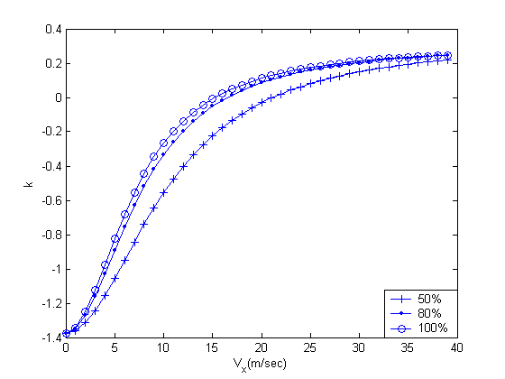
Fig. 4. Steering ratio k vs. forward speed in steady turning with 50%, 80% and 100% fill level.

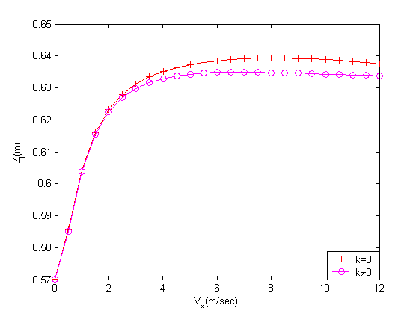

Fig 5. The comparison of vertical translations of center of mass of liquid Z_{l} due to the change in forward speed of 80% filled tank vehicle between multiple steer (k≠0) and single steer (k=0).

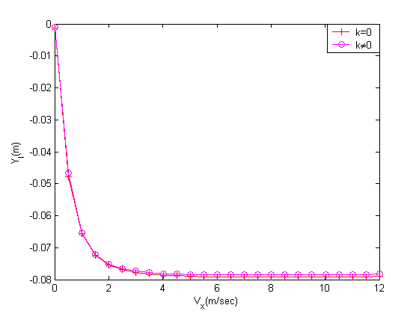
Fig. 6. The comparison of lateral translation of center of mass of liquid Y_{l} due to the change in forward speed of 80% filled tank vehicle between multiple steer (k≠0) and single steer (k=0).
Fig. 7. The comparisons of inclination angle of the liquid free surface vs. forward speed of 80% filled tank vehicle between multiple steer (k≠0) and single steer (k=0).

Table 1. Specific data for the tank vehicle.
Mass | 5180 kg
Liquid mass | 30%: 1057 kg；50%: 2093 kg;  80%: 3589 kg ; 100%: 4186 kg
Tank dimensions | 4.31m×1.3m×1.3m
Torsional spring K_{θ} | 90000 Nm/rad
Roll damping coefficient C_{θ} | 6000 Nmsec/rad
S₁ | 1.6 m
S₂ | 2.2 m
ε_{f} | 0.19
ε_{r} | 0.024
C_{f} | -29532 N/rad
C_{r} | -59064 N/rad

As known, the lateral force could change yaw direction and lead to the rollover. First, Figs. 8 and 9 show the gradient of free surface with respect to tank fixed axes due to change in vehicle lateral acceleration for 2 degrees and 8 degrees tank roll angles respectively. The results show that the gradient of free surface increases with increase in lateral acceleration for a constant tank roll angle. The proposed model obtains better stability of liquid surface than the single steer tank does. Next, the multi-steering-axle model is demonstrated for a steady state turning input 10 degrees and a speed 12 m/sec. Figures 10 and 11 indicate the comparison of the lateral acceleration related to the forward speed between the additional steering axle and traditional tank vehicles with 80% and 100% fill level, respectively. From the plots, it shows that consideration of multiple steering wheels model does affect the lateral accelerations during the steady state turning. Therefore, the additional steering axle plays an important role in lateral dynamics.

Fig.8. The comparisons of gradient of free surface of liquidφ due to change in lateral acceleration of 80% filled for roll angle 2 degrees between multiple steer (k≠0) and single steer (k=0).

Fig.9. The comparisons of gradient of free surface of liquidφdue to change in lateral acceleration of 80% filled for roll angle 6 degrees between multiple steer (k≠0) and single steer (k=0).

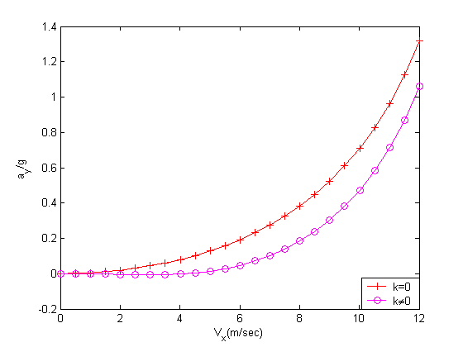
Fig. 10. The comparisons of lateral acceleration vs. forward speed of 80% filled tank vehicle with multiple steer (k≠0) and single steer (k=0) during steady steering.
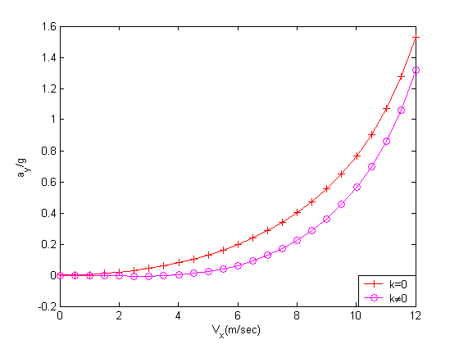

Fig. 11. The comparisons of lateral acceleration vs. forward speed of 100% filled tank vehicle with multiple steer (k≠0) and single steer (k=0) during steady steering.

To understand the influence of variation of steer angle and the fill level on lateral acceleration of the tank vehicle in steady turning, the following investigations have been made. Figures 12 and 13 show the comparisons of the conventional single steer system and the proposed model in the influence of the increasing steering angle on the lateral acceleration at slow speed of 12 m/sec with 80% and 100% fill level respectively. The results reveal the multi-steering-axle model has better maneuverability than that of single steering model during steady turning.
In order to compare the multi-axle-steering model to traditional model during turning maneuverability, an understeer vehicle with positive value of K_{us} is chosen. Assume the tank vehicle travels in steady-state steering at low speed under various partial-fill conditions. Figures 14 and 15 show the comparison of the rotation radius in the conventional single steer system and the multi-steering-alxe model during different steering angle input, speed of 12 m/sec with 80% and 100% fill level respectively. The results show the proposed model have the shorter turning radius compared to that of single steering axle model to finish the turn in the same front steering angle.

CONCLUSIONS

A roll/yaw multi-axe-steering model is developed to establish the roll behavior of a partially filled tank truck. The proposed model reveals significantly lower lateral acceleration and radius of turning when compared to the corresponding ones obtained by the traditional single steering model. Computer simulations of proposed model analytically show the multiple steering wheels do decrease the lateral acceleration, and reduce the rotation radius in steady-state steering about its equilibrium position as expected. The magnitudes of vertical and lateral translations of the centre of mass of liquid and gradient of free surface are observed to be smaller due to the multiple steering. There are many subjects left and needed to be studied such as load transfer effect to rollover, response to a sinusoidal input, and non-steady turning. These could be very interesting work for future research. To perform a comprehensive examination of vehicle handling qualities, the characteristics of a human driver therefore should be included. This topic is, however, beyond the scope of the present study.

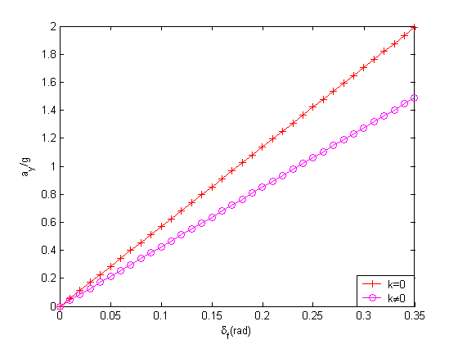

Fig. 12. The comparisons of lateral acceleration vs. steering angle(δ_{f}) of 80% filled tank vehicle with slow speed 12 m/sec with multiple steering (k≠0) and single steering (k=0) during steady steering.

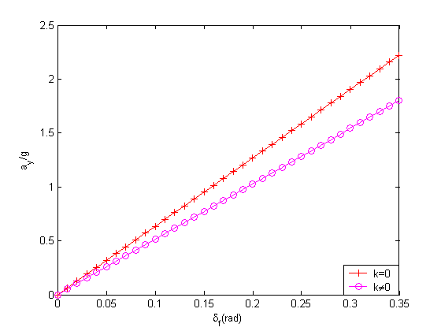

Fig. 13. The comparisons of lateral acceleration vs. steering angle (δ_{f}) of 100% filled tank vehicle with slow speed 12 m/sec with multiple steer (k≠0) and single steer(k=0) during steady steering.
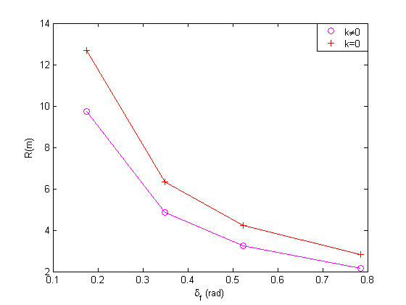

Fig. 14. The comparisons of rotation radius vs. steering angle(δ_{f}) of 80% filled tank vehicle with slow speed 12 m/sec with multiple steer(k≠0) and single steer(k=0) during steady state turning.

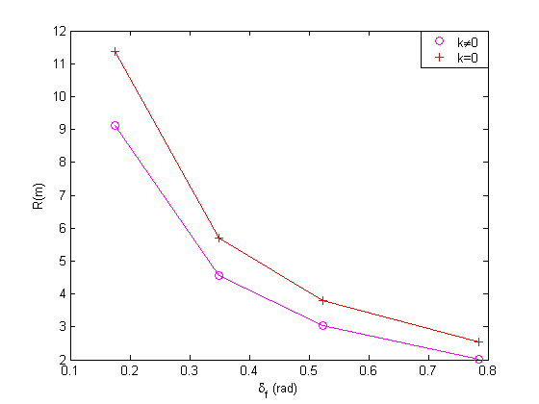

Fig. 15. The comparisons of rotation radius vs. steering angle(δ_{f}) of 100% filled tank vehicle with slow speed 12 m/sec with multiple steer(k≠0) and single steer(k=0) during steady state turning.

ACKNOWLEDGMENT

Financial support for this work was provided by the National Science Council Taiwan, R.O.C, under the contract NSC 91-2212-E020-004.

REFERENCES

Aurell, J. and Edlund, S., “The Influence of Steered Axles on the Dynamic Stability of Heavy Vehicles,” SAE paper No. 892498 (1989).
Bernard, J.E., Vanderploeg, M.J., and Shannan, J.E, “Linear Analysis of a Vehicle with Four-Wheel Steering,” SAE paper No. 880643 (1988).
Furleigh, D.D., Vanderploeg, M.J., and Oh, C.Y., “Multiple Steered Axles for Reducing the Rollover Risks of Heavy Articulated Trucks,” SAE paper No.881866 (1988).
Kang, X, Rakheja, S. and Stiharu, I., “Effects of Tank Shape on the Roll Dynamic Response of a Partly Filled Tank Vehicle,” Veh. Sys. Dyn., Vol.35, No.2, pp.75-102 (2000).
LeBlane, P.A., El-Gindy, M. and Woodrooffe, J.H.F., “Self-steering axles:Theory and Practice,” SAE paper No.891633 (1989).
Rakheja, S., “Roll Plane Analysis of Articulated Tank Vehicles During Steady Turning,” Veh. Sys. Dyn., Vol. 17, pp.81-104 (1988).
Ranganathan, R., Rakheja, S., Sankar, S., ”Steady Turning Stability of Partially Filled Tank Vehicles With Arbitrary Tank Geometry,” J. Dyn. Sys. Measur. Contr., Vol. 111, No. 3,pp. 481-489 (1989).
Ranganathan, R., “Influence of Liquid Load Shift on the Dynamic Response of Articulated Tank Vehicles,” Veh. Sys. Dyn., Vol.19, pp.177-200 (1990).
Sano, S., Furukawa, Y. and Shiraishi, S., “Four-Wheel Steering System with Rear Wheel Steer Angle Controlled as a Function of Steering Wheel Angle,” SAE Trans. paper 860625 (1986).
Wang, J.Y., Theory of Ground Vehicles, John Wiely, New York (1993).
Wu, D-H, “A Theoretic Study for Yaw/Roll Motions of Multiple Steering Articulated Vehicle,” Pro. I. Mech. Eng. Part D., Vol. 215, pp.1257-1265 (2001).

APPENDIX

I. The following elements M_{ij} , C_{ij} , K_{ij} and L_{ij} represents the row and j represents the column for matrices [M], [C], [K], and {L} respectively.
Elements of matrix [M]:

M₁₁ = m , M₁₂ = 0 , M₁₃ = -m_{l}Z_{l} ,

M₂₁ = 0, M₂₂ = Iz – m_{l}Y_{l}² , M₂₃ = ﹣I_{xz}

M₃₁ = ﹣m_{l}Z_{l} , M₃₂ = ﹣I_{xz} , M₃₃ = I_{xs} + m_{l} (Z_{l}² - Y_{l}² ).

Elements of matrix [C]:

C₁₁ = ﹣2{(C_{f} + C_{r} ) / V_{x}} , C₁₂ = m₁ V_{x} ﹣2{C_{f}s₁ ﹣C_{r}s₂ )} / V_{x} , C₁₃ = 0 ,

C₂₁ = ﹣2(C_{f}s₁ ﹣C_{r}s₂ ) / V_{x} , C₂₂ = ﹣2(C_{f}s₁² + C_{r}s₂² ) / V_{x ,} C₂₃ = 0 ,

C₃₁ = 0, C₃₂ =﹣m_{l}Z_{l}V_{x} , C₃₃ = C_{θ}.

Elements of matrix [K]:

K₁₁ = 0 , K₁₂ = 0 , K₁₃ = 2(C_{f}ε_{f} + C_{r}ε_{r}) ,

K₂₁ = 0 , K₂₂ = 0 , K₂₃ = 2(C_{f}s₁ε_{f} ﹣C_{r}s₂ε_{r)} ,

K₃₁ = 0 , K₃₂ = 0 , M₃₃ = (K_{θ} ﹣m_{l}gZ_{l}).

Elements of vector {L}:

L₁₁ = ﹣2(C_{f} + kC_{r}) , L₂₁ = ﹣2(C_{f}s₁ ﹣kC_{r} s₂) ,
L₃₁ = m_{l}gY_{l.}

II.
$L_{θ}=−k_{θ}+m_{l}{\text{gZ}}_{l}$，$Y_{δ}=−2\left(C_{f}+{\text{kC}}_{r}\right)$，$Y_{β}=2\left(C_{f}+C_{r}\right)$，$N_{r}=2{\left(C_{f}S_{1^{2}}+C_{r}S_{2^{2}}\right)}/{V_{x}}$，$N_{δ}=−2\left(C_{f}S_{1}−{\text{kC}}_{r}S_{2}\right)$，$N_{θ}=−2\left(C_{f}S_{1}ε_{f}−C_{r}S_{2}ε_{r}\right)$，$N_{β}=\frac{2\left(C_{f}S_{1}−C_{r}S_{2}\right)}{V_{x}}$，$Y_{θ}=−2\left(C_{f}ε_{f}+C_{r}ε_{r}\right)$，$Y_{r}=2{\left(C_{f}S_{1}−C_{r}S_{2}\right)}/{V_{x}}$.

NOMENCLATURE

C_{θ} roll damping coefficient

F_{yf} the lateral force in front wheels

F_{yr} the lateral force in rear wheels

I_{z} principal yaw moment of inertia of the mass of vehicle

I_{xs} vehicle sprung mass about x axis

I_{xz} the product of inertia for the vehicle

K_{θ} roll stiffness coefficient

m total mass of vehicle

m_{s} sprung mass of tractor

m_{l} mass of liquid

s₁ distance between front axle and mass center

s₂ distance between rear axle and mass center

V_{x} speed in the X direction

V_{y} speed in the Y direction

δ_{f} the steer angle of front wheel

δ_{r} the steer angle of towed unit front wheel

Φ the yaw angle of vehicle

θ the roll angle of the sprung mass of vehicle

ε_{f} the front roll steer coefficient

ε_{r} the rear roll steer coefficient

多軸轉向液態罐裝車之穩態轉向研究

吳德和 簡文通 林育弘
國立屏東科技大學機械工程學系

摘 要
本文旨在探討液態原料罐裝車穩態轉彎行駛時因液體飛濺，使荷重移動，造成重心位置大量偏移，整個系統穩定性發生重大變化可能造成車輛傾覆。本文建立一套新罐裝車模型，是屬於前後軸皆可轉向的罐裝車輛。前後軸皆可轉向的主要優點，可降低轉彎時產生之側向力、增加行駛之穩定性與操控性能。由於側向加速度是影響車子側翻最重要的因素，因此本文將藉由推得之罐裝車運動方程式，對不同異丙稀載重比例之車輛進行研究，主要內容包括裝有不同比例異丙烯時前後輪轉向比與車輛行駛速度之關係，及探討低速穩態轉向行駛之側向加速度與速度及旋轉半徑之關係。

